1.

Convert 320_{five} to a base ten numeral.
A.
25
B.
77
C.
85
D.
86
E.
90

2.

P = {2, 4, 6, 8} and Q = {even counting numbers less than 12}.
What is the relationship between P and Q?
A.
P = Q
B.
P ⊂ Q
C.
P < Q
D.
Q ⊂ P
E.
P ∈ Q

3.

In the diagram below, P is the set of numbers in the circle and Q is the set of numbers in the triangle.
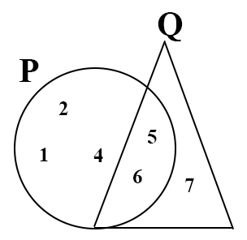
What is P ∩ Q?
A.
{1, 2, 4}
B.
{5, 6}
C.
{7}
D.
{1, 2, 4, 5, 6, 7}
E.
{ }

4.

The product 6287 x 543 = 3,413,841.
What is the value of 628.7 x 5.43?
A.
3,413,841
B.
342,384.1
C.
34,138.41
D.
3,413.841
E.
341.3841

5.

Express 30 cm as a percentage of 2 m.
A.
0.5%
B.
1.5%
C.
6.7%
D.
15%
E.
66.7%

6.

What solid can be made from this net?
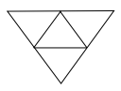
A.
triangle
B.
rectangular pyramid
C.
triangular prism
D.
rectangular prism
E.
triangular pyramid

7.

Simplify 3(6b – 9a) + 7(6a – 5b)
A.
17b + 6a
B.
-17b + 6a
C.
17b + 48a
D.
15a – 17b
E.
17b – 15a

8.

Arrange the following fractions in descending order
9
16
,
5
8
, 0.62
A.
9
16
, 0.62,
5
8
B.
0.62,
5
8
,
9
16
C.
5
8
,
9
16
, 0.62
D.
5
8
, 0.62,
9
16
E.
0.62,
9
16
,
5
8

9.

18 = 2 x 3²; 42 = 2 x 3 x 7; 90 = 2 x 3² x 5
Use the information above to answer the question below.
Find the LCM of 18, 42 and 90.
A.
2 × 3²
B.
2 × 3 × 7
C.
2 × 3² × 5
D.
2 × 3 × 5 × 7
E.
2 × 3² × 5 × 7

10.

18 = 2 x 3²; 42 = 2 x 3 x 7; 90 = 2 x 3² x 5
Use the information above to answer the question below.
What is the HCF of 18, 42 and 90?
A.
21
B.
18
C.
9
D.
6
E.
3

11.

Simplify
(
4
5
)
+
(
-2
2
)
+
(
1
6
)
A.
(
2
13
)
B.
(
3
13
)
C.
(
5
13
)
D.
(
6
13
)
E.
(
7
13
)

12.

If R =
1
2
(a + b)k, find k in terms of R, a and b.
A.
a + b
2R
B.
2R
a + b
C.
2R - a
b
D.
2R - b
a
E.
R
2(a + b)

13.

In the following figure below, triangle M′ON′ is an enlargement of triangle MON, with centre O.
Use this information to answer the question below
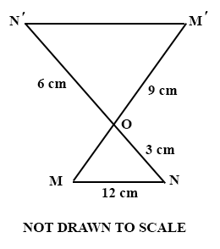
Find the scale factor of the enlargement
A.
9
B.
3
C.
2
D.
–2
E.
–3

14.

In the following figure below, triangle M′ON′ is an enlargement of triangle MON, with centre O.
Use this information to answer the question below
Find OM
A.
9
B.
6
C.
4.5
D.
3
E.
1.5

15.

Find the image of the point (6, 3) when translated by the vector
(
-4
-1
)
.
A.
(-2, -2)
B.
(2, -2)
C.
(-2, 2)
D.
(2, 2)
E.
(10, 4)

16.

A student spends
17
35
of his pocket money on transport and fruits. He spends
5
6
of the remainder on sweets. What fraction of his pocket money does he spend on sweets?
A.
4
7
B.
3
7
C.
17
35
D.
18
35
E.
17
42

17.

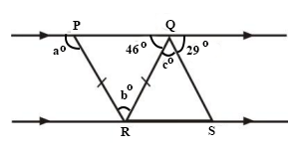
In the diagram above, PQ is parallel to RS and |PR| = |QR|.
Use the diagram to answer the question below.
What is a?
A.
29
B.
46
C.
75
D.
88
E.
134

18.

In the diagram above, PQ is parallel to RS and |PR| = |QR|.
Use the diagram to answer the question below.
Find b.
A.
29
B.
46
C.
88
D.
92
E.
105

19.

In the diagram above, PQ is parallel to RS and |PR| = |QR|.
Use the diagram to answer the question below.
Find the value of c.
A.
29
B.
46
C.
75
D.
88
E.
105

20.

If p = 7, q = 5 and r = 3, find the value of p² + q – r³.
A.
10
B.
27
C.
51
D.
57
E.
81

21.

Simplify 35x⁵y³ ÷ 7xy²
A.
5x⁶y⁵
B.
5x⁴y
C.
5x⁶y
D.
5x⁴y⁵
E.
5x⁴y

22.

The sum of two numbers is 240. If one of them is y, find the other number.
A.
120y
B.
240 + y
C.
240 – y
D.
240y
E.
240/y

23.

Make n the subject of the relation 2n + 5 = 7a
A.
n =
1
2
(7a + 5)
B.
n =
1
2
(7a - 5)
C.
n = 2(7a + 5)
D.
n = 2(7a - 5)
E.
n = 7a - 5

24.

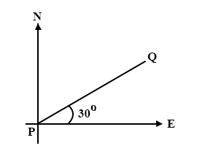
Find the bearing of Q from P in the diagram above.
A.
030°
B.
060°
C.
070°
D.
090°
E.
150°

25.

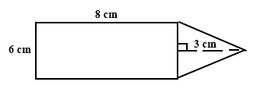
The figure above is made up of a rectangle and a triangle. The dimensions of the rectangle are 8 cm and 6 cm. The triangle has 6 cm as its base and 3 cm as its height.
Find the area of the figure.
A.
33 cm²
B.
48 cm²
C.
51 cm²
D.
57 cm²
E.
66 cm²

26.

The marks obtained by 10 boys in a test are 0, 1, 3, 3, 5, 7, 8, 9, 9, 9.
Use this information to answer the question below
Find the median score.
A.
3
B.
5
C.
6
D.
7
E.
8

27.

The marks obtained by 10 boys in a test are 0, 1, 3, 3, 5, 7, 8, 9, 9, 9.
Use this information to answer the question below
Calculate the mean score.
A.
4.4
B.
5.4
C.
6.0
D.
6.4
E.
9.0

28.

The marks obtained by 10 boys in a test are 0, 1, 3, 3, 5, 7, 8, 9, 9, 9.
Use this information to answer the question below
What is the probability that a boy chosen at random scored 3?
A.
1
27
B.
1
18
C.
1
10
D.
1
5
E.
1
3

29.

Express 57_{ten} as a base two (binary) numeral.
A.
101011_{two}
B.
100111_{two}
C.
11010_{two}
D.
110111_{two}
E.
111001_{two}

30.

The scale of a map is 1 : 100,000. What is the distance (in km) between two towns 4 cm apart on the map?
A.
0.04
B.
0.4
C.
4.0
D.
40
E.
400

31.

If 22% of a rope is 55 m long, find the full length of the rope.
A.
12.1 m
B.
25 m
C.
121 m
D.
250 m
E.
2500 m

32.

Adwoa and Ama share an amount of ₵6,000.00 in the ratio 3 : 2. Find Adwoa's share.
A.
₵2,000.00
B.
₵2,400.00
C.
₵3,000.00
D.
₵3,600.00
E.
₵4,000.00

33.

Find the truth set of 5x – 8 ≤ 2x + 4.
A.
{x ≥ 4}
B.
{x ≥ -4}
C.
{x ≤ 4}
D.
{x ≤ -4}
E.
{x = 4}

34.

The diameter of a circular tray is 28 cm. Find the area of the tray.
[Take π =
22
7
]
A.
44 cm²
B.
88 cm²
C.
154 cm²
D.
616 cm²
E.
2464 cm²

35.

If a =
(
3
3
)
and b =
(
5
-5
)
, find a + b.
A.
(
2
8
)
B.
(
8
8
)
C.
(
2
2
)
D.
(
8
-8
)
E.
(
8
-2
)

36.

x | 0 | 1 | 2 | 3 | 4
↓ | ↓ | ↓ | ↓ | ↓ | ↓
y | 0 | 1 | 4 | 9 | 16
What is the rule for the mapping above?
A.
x→x + 3
B.
x→x + 1
C.
x→x - 1
D.
x→x + 2
E.
x→x²

37.

If 50 oranges cost ₵2,500.00 how many oranges can be bought for ₵15,000.00?
A.
3
B.
30
C.
60
D.
300
E.
360

38.

A farmer has 1853 pineapple suckers. He plants 17 pineapples in a row. How many rows can he plant?
A.
17
B.
19
C.
91
D.
109
E.
190

39.

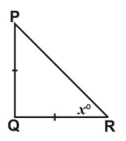
In triangle PQR, |PQ| = |QR|, and angle PQR = 90°.
Find x.
A.
30°
B.
45°
C.
60°
D.
90°
E.
180°

40.

If a × b × c = 1197 and a = 21, b = 3, find c.
A.
19
B.
49.9
C.
57
D.
63
E.
399

